Folder Hierarchy

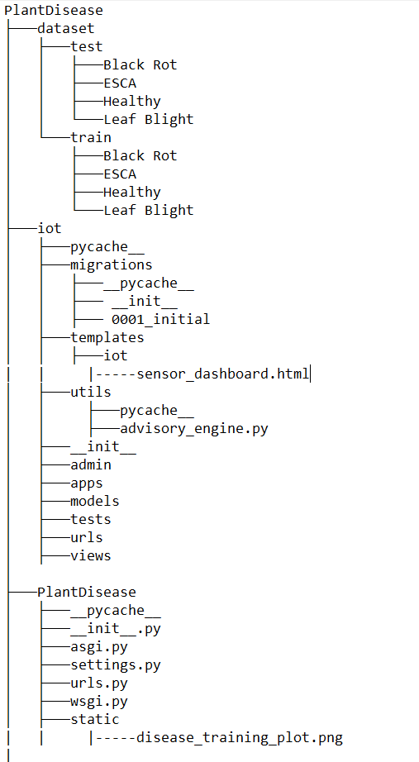
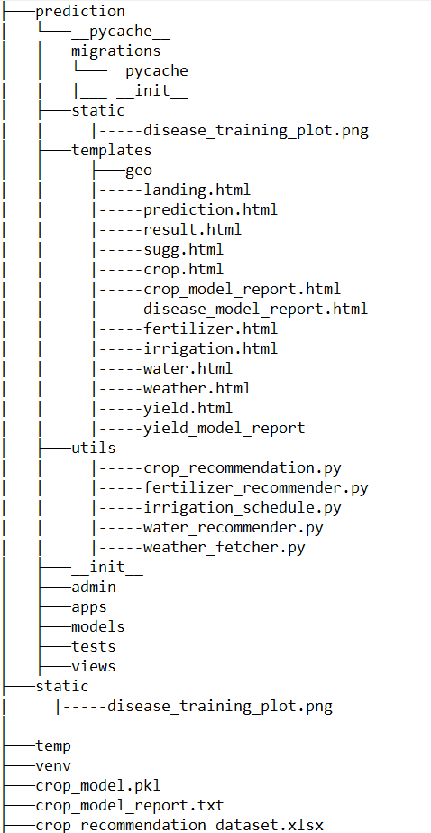
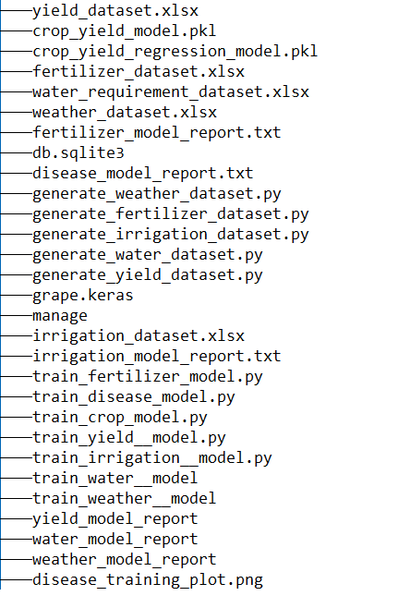

_____________________________________________________________________________
File Contents
------------------------------------------------------------------------------------------------------------------
- C:\Users\hp\Desktop\Smart farming-gpt\PlantDisease\iot\migrations\0001_initial
# Generated by Django 5.2.1 on 2025-05-11 20:36
import django.utils.timezone
from django.db import migrations, models
class Migration(migrations.Migration):
initial = True
dependencies = [
]

operations = [
migrations.CreateModel(
name='SensorData',
fields=[
('id', models.BigAutoField(auto_created=True, primary_key=True, serialize=False, verbose_name='ID')),
('timestamp', models.DateTimeField(default=django.utils.timezone.now)),
('temperature', models.FloatField()),
('humidity', models.FloatField()),
('soil_moisture', models.FloatField()),
('crop_health', models.FloatField()),
],
),
]
- C:\Users\hp\Desktop\Smart farming-gpt\PlantDisease\iot\templates\iot\sensor_dashboard
{% load static %}
<!DOCTYPE html>
<html lang="en">
<head>
<meta charset="UTF-8">
<title>IoT Sensor Dashboard</title>
<link rel="stylesheet" href="{% static 'css/style.css' %}">
<link href="https://cdn.jsdelivr.net/npm/bootstrap@5.3.0/dist/css/bootstrap.min.css" rel="stylesheet">
<script src="https://cdn.jsdelivr.net/npm/chart.js"></script>
</head>
<body class="bg-light">
<div class="container py-5">
<h2 class="text-center mb-4">🌾 Real-Time IoT Sensor Dashboard</h2>

<form method="post" class="text-center mb-4">
{% csrf_token %}
<button type="submit" class="btn btn-success">Simulate New Reading</button>
</form>
{% if alerts %}
<div class="alert alert-warning text-start">
<ul class="mb-0">
{% for msg in alerts %}
<li>{{ msg }}</li>
{% endfor %}
</ul>
</div>
{% endif %}

<!-- Table for displaying latest values -->
<div class="table-responsive mb-5">
<table class="table table-bordered table-striped text-center">
<thead class="table-dark">
<tr>
<th>Timestamp</th>
<th>Temp (°C)</th>
<th>Humidity (%)</th>
<th>Soil Moisture (%)</th>
<th>Crop Health (%)</th>
</tr>
</thead>
<tbody>
{% for row in data %}
<tr>
<td>{{ row.timestamp }}</td>
<td>{{ row.temperature }}</td>
<td>{{ row.humidity }}</td>
<td>{{ row.soil_moisture }}</td>
<td>{{ row.crop_health }}</td>
</tr>
{% endfor %}
</tbody>
</table>
</div>

<!-- Graphs -->
<div class="row">
<div class="col-md-6">
<canvas id="tempChart"></canvas>
</div>
<div class="col-md-6">
<canvas id="moistureChart"></canvas>
</div>
<div class="col-md-6 mt-4">
<canvas id="humidityChart"></canvas>
</div>
<div class="col-md-6 mt-4">
<canvas id="healthChart"></canvas>
</div>
</div>

<div class="text-center mt-4">
<a href="/" class="btn btn-secondary">Back to Home</a>
</div>
</div>

<script>
const tempCtx = document.getElementById('tempChart').getContext('2d');
const moistureCtx = document.getElementById('moistureChart').getContext('2d');
const humidityCtx = document.getElementById('humidityChart').getContext('2d');
const healthCtx = document.getElementById('healthChart').getContext('2d');

const createChart = (ctx, label, borderColor) => new Chart(ctx, {
type: 'line',
data: {
labels: [],
datasets: [{
label: label,
data: [],
borderColor: borderColor,
tension: 0.3
}]
},
options: {
animation: false,
scales: { y: { beginAtZero: true } }
}
});

const tempChart = createChart(tempCtx, 'Temperature (°C)', 'red');
const moistureChart = createChart(moistureCtx, 'Soil Moisture (%)', 'blue');
const humidityChart = createChart(humidityCtx, 'Humidity (%)', 'green');
const healthChart = createChart(healthCtx, 'Crop Health (%)', 'purple');

function updateCharts() {
fetch('/iot/api/data/')
.then(response => response.json())
.then(data => {
tempChart.data.labels = data.labels;
tempChart.data.datasets[0].data = data.temperature;
tempChart.update();

moistureChart.data.labels = data.labels;
moistureChart.data.datasets[0].data = data.moisture;
moistureChart.update();

humidityChart.data.labels = data.labels;
humidityChart.data.datasets[0].data = data.humidity;
humidityChart.update();

healthChart.data.labels = data.labels;
healthChart.data.datasets[0].data = data.crop_health;
healthChart.update();
});
}

updateCharts();
setInterval(updateCharts, 10000); // refresh every 10 seconds
</script>
</body>
</html>

- C:\Users\hp\Desktop\Smart farming-gpt\PlantDisease\iot\utils\advisory_engine.py
def generate_alerts(sensor):
alerts = []

if sensor.temperature > 32 and sensor.soil_moisture < 25:
alerts.append("⚠️ Heat stress risk! Consider light irrigation.")

if sensor.humidity > 80 and sensor.soil_moisture > 40:
alerts.append("🌧️ High moisture & humidity — skip irrigation.")

if sensor.crop_health < 65:
alerts.append("🪲 Low crop health — check for pests or nutrient issues.")

if not alerts:
alerts.append("✅ All conditions are optimal.")

return alerts

- C:\Users\hp\Desktop\Smart farming-gpt\PlantDisease\iot\admin.py
from django.contrib import admin

# Register your models here.

- C:\Users\hp\Desktop\Smart farming-gpt\PlantDisease\iot\apps.py
from django.apps import AppConfig

class IotConfig(AppConfig):
default_auto_field = 'django.db.models.BigAutoField'
name = 'iot'

- C:\Users\hp\Desktop\Smart farming-gpt\PlantDisease\iot\models.py
from django.db import models
from django.utils import timezone

class SensorData(models.Model):
timestamp = models.DateTimeField(default=timezone.now)
temperature = models.FloatField()
humidity = models.FloatField()
soil_moisture = models.FloatField()
crop_health = models.FloatField()

def __str__(self):
return f"{self.timestamp} - Temp: {self.temperature}, Moisture: {self.soil_moisture}"

# Create your models here.

- C:\Users\hp\Desktop\Smart farming-gpt\PlantDisease\iot\tests.py
from django.test import TestCase

# Create your tests here.

- C:\Users\hp\Desktop\Smart farming-gpt\PlantDisease\iot\urls.py
from django.urls import path
from . import views

urlpatterns = [
path('dashboard/', views.simulate_sensor_data, name='sensor_dashboard'),
path('dashboard/', views.simulate_sensor_data, name='sensor_dashboard'),
path('api/data/', views.sensor_data_api, name='sensor_data_api'), # 👈 Add this

]

- C:\Users\hp\Desktop\Smart farming-gpt\PlantDisease\iot\views.py
from django.shortcuts import render
from .models import SensorData
from django.http import JsonResponse
import random
from .utils import advisory_engine # ✅ required for alerts

# Simulate data entry using geo session values
def simulate_sensor_data(request):
data = SensorData.objects.all().order_by('-timestamp')[:10]
alerts = []

if request.method == 'POST':
geo_data = request.session.get('geo_sensor')

if geo_data:
new_data = SensorData.objects.create(
temperature=geo_data["temperature"],
humidity=geo_data["humidity"],
soil_moisture=geo_data["soil_moisture"],
crop_health=geo_data["crop_health"]
)
alerts = advisory_engine.generate_alerts(new_data)
else:
alerts.append("⚠️ No geo data found. Please go to /geo/ and submit a location.")

data = SensorData.objects.all().order_by('-timestamp')[:10]

return render(request, 'iot/sensor_dashboard.html', {
'data': data,
'alerts': alerts
})

# Serve data for charts
def sensor_data_api(request):
latest = SensorData.objects.order_by('-timestamp')[:10]
data = {
"labels": [s.timestamp.strftime("%H:%M:%S") for s in reversed(latest)],
"temperature": [s.temperature for s in reversed(latest)],
"humidity": [s.humidity for s in reversed(latest)],
"moisture": [s.soil_moisture for s in reversed(latest)],
"crop_health": [s.crop_health for s in reversed(latest)],
}
return JsonResponse(data)

- C:\Users\hp\Desktop\Smart farming-gpt\PlantDisease\PlantDisease\asgi.py
"""
ASGI config for PlantDisease project.
It exposes the ASGI callable as a module-level variable named ``application``.
For more information on this file, see
https://docs.djangoproject.com/en/3.2/howto/deployment/asgi/
"""
import os
from django.core.asgi import get_asgi_application
os.environ.setdefault('DJANGO_SETTINGS_MODULE', 'PlantDisease.settings')
application = get_asgi_application()
- C:\Users\hp\Desktop\ Smart farming-gpt\PlantDisease\PlantDisease\settings.py
"""
Django settings for PlantDisease project.

Generated by 'django-admin startproject' using Django 3.2.8.

For more information on this file, see
https://docs.djangoproject.com/en/3.2/topics/settings/

For the full list of settings and their values, see
https://docs.djangoproject.com/en/3.2/ref/settings/
"""

from pathlib import Path

# Build paths inside the project like this: BASE_DIR / 'subdir'.
BASE_DIR = Path(__file__).resolve().parent.parent
# Quick-start development settings - unsuitable for production
# See https://docs.djangoproject.com/en/3.2/howto/deployment/checklist/

# SECURITY WARNING: keep the secret key used in production secret!
SECRET_KEY = 'django-insecure-u#5pkq)(lf-hy*14v78+d=#7=4t*f_8+y8&owl54n6yqdw2dy$'

# SECURITY WARNING: don't run with debug turned on in production!
DEBUG = True

ALLOWED_HOSTS = []

# Application definition

INSTALLED_APPS = [
'prediction',
'django.contrib.admin',
'django.contrib.auth',
'django.contrib.contenttypes',
'django.contrib.sessions',
'django.contrib.messages',
'django.contrib.staticfiles',
]

MIDDLEWARE = [
'django.middleware.security.SecurityMiddleware',
'django.contrib.sessions.middleware.SessionMiddleware',
'django.middleware.common.CommonMiddleware',
'django.middleware.csrf.CsrfViewMiddleware',
'django.contrib.auth.middleware.AuthenticationMiddleware',
'django.contrib.messages.middleware.MessageMiddleware',
'django.middleware.clickjacking.XFrameOptionsMiddleware',
]

ROOT_URLCONF = 'PlantDisease.urls'

TEMPLATES = [
{
'BACKEND': 'django.template.backends.django.DjangoTemplates',
'DIRS': [],
'APP_DIRS': True,
'OPTIONS': {
'context_processors': [
'django.template.context_processors.debug',
'django.template.context_processors.request',
'django.contrib.auth.context_processors.auth',
'django.contrib.messages.context_processors.messages',
],
},
},
]

WSGI_APPLICATION = 'PlantDisease.wsgi.application'
# Database
# https://docs.djangoproject.com/en/3.2/ref/settings/#databases

DATABASES = {
'default': {
'ENGINE': 'django.db.backends.sqlite3',
'NAME': 'db.sqlite3',
}
}

# Password validation
# https://docs.djangoproject.com/en/3.2/ref/settings/#auth-password-validators

AUTH_PASSWORD_VALIDATORS = [
{
'NAME': 'django.contrib.auth.password_validation.UserAttributeSimilarityValidator',
},
{
'NAME': 'django.contrib.auth.password_validation.MinimumLengthValidator',
},
{
'NAME': 'django.contrib.auth.password_validation.CommonPasswordValidator',
},
{
'NAME': 'django.contrib.auth.password_validation.NumericPasswordValidator',
},
]

# Internationalization
# https://docs.djangoproject.com/en/3.2/topics/i18n/

LANGUAGE_CODE = 'en-us'

TIME_ZONE = 'UTC'

USE_I18N = True

USE_L10N = True

USE_TZ = True
# Static files (CSS, JavaScript, Images)
# https://docs.djangoproject.com/en/3.2/howto/static-files/

STATIC_URL = '/static/'

# Default primary key field type
# https://docs.djangoproject.com/en/3.2/ref/settings/#default-auto-field

DEFAULT_AUTO_FIELD = 'django.db.models.BigAutoField'

- C:\Users\hp\Desktop\ Smart farming-gpt\PlantDisease\PlantDisease\urls.py
from django.contrib import admin
from django.urls import path, include
from prediction.views import (
home,
prediction,
yield_prediction_view,
fertilizer_view,
water_view,
irrigation_view,
crop_view,
weather_view,
geo_dashboard,
yield_model_report_view,
crop_model_report_view,
disease_model_report_view,
reset_predictions,
reset_fertilizer_log,
reset_water_log,
reset_irrigation_log,
reset_weather_log,
reset_yield_log
)

urlpatterns = [
path('admin/', admin.site.urls),
path('', home, name='home'),

# Prediction and related tools
path('prediction/', prediction, name='prediction'),
path('prediction/reset/', reset_predictions, name='reset_predictions'),
path('fertilizer/reset/', reset_fertilizer_log, name='reset_fertilizer'),
path('water/reset/', reset_water_log, name='reset_water'),
path('irrigation/reset/', reset_irrigation_log, name='reset_irrigation'),
path('weather/reset/', reset_weather_log, name='reset_weather'),
path('yield/reset/', reset_yield_log, name='reset_yield'),

# Feature views
path('yield/', yield_prediction_view, name='yield_predictions'),
path('fertilizer/', fertilizer_view, name='fertilizer'),
path('water/', water_view, name='water'),
path('irrigation/', irrigation_view, name='irrigation'),
path('crop/', crop_view, name='crop'),
path('weather/', weather_view, name='weather'),

# External integrations
path('iot/', include('iot.urls')),
path('geo/', geo_dashboard, name='geo_dashboard'),

# Model reports
path('yield/report/', yield_model_report_view, name='yield_model_report'),
path('crop/report/', crop_model_report_view, name='crop_model_report'),
path('disease/report/', disease_model_report_view, name='disease_model_report'),
]

- C:\Users\hp\Desktop\ Smart farming-gpt\PlantDisease\PlantDisease\wsgi.py
"""
WSGI config for PlantDisease project.

It exposes the WSGI callable as a module-level variable named ``application``.

For more information on this file, see
https://docs.djangoproject.com/en/3.2/howto/deployment/wsgi/
"""

import os

from django.core.wsgi import get_wsgi_application

os.environ.setdefault('DJANGO_SETTINGS_MODULE', 'PlantDisease.settings')

application = get_wsgi_application()

- C:\Users\hp\Desktop\Smart farming-gpt\PlantDisease\prediction\static\disease_training_plot.png
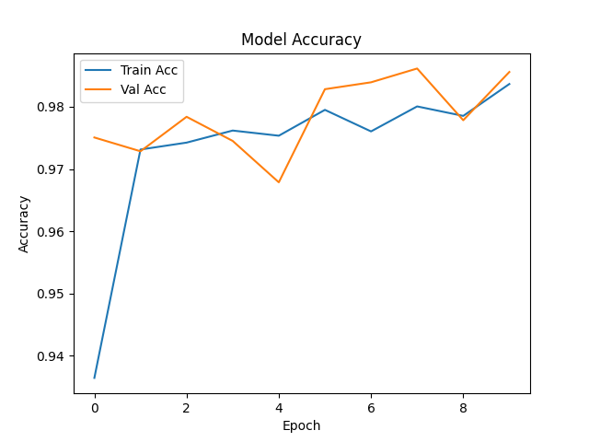
- Smart Farming System (C:\Users\hp\Desktop\ Smart farming-gpt\PlantDisease\prediction\templates\.landing.html)
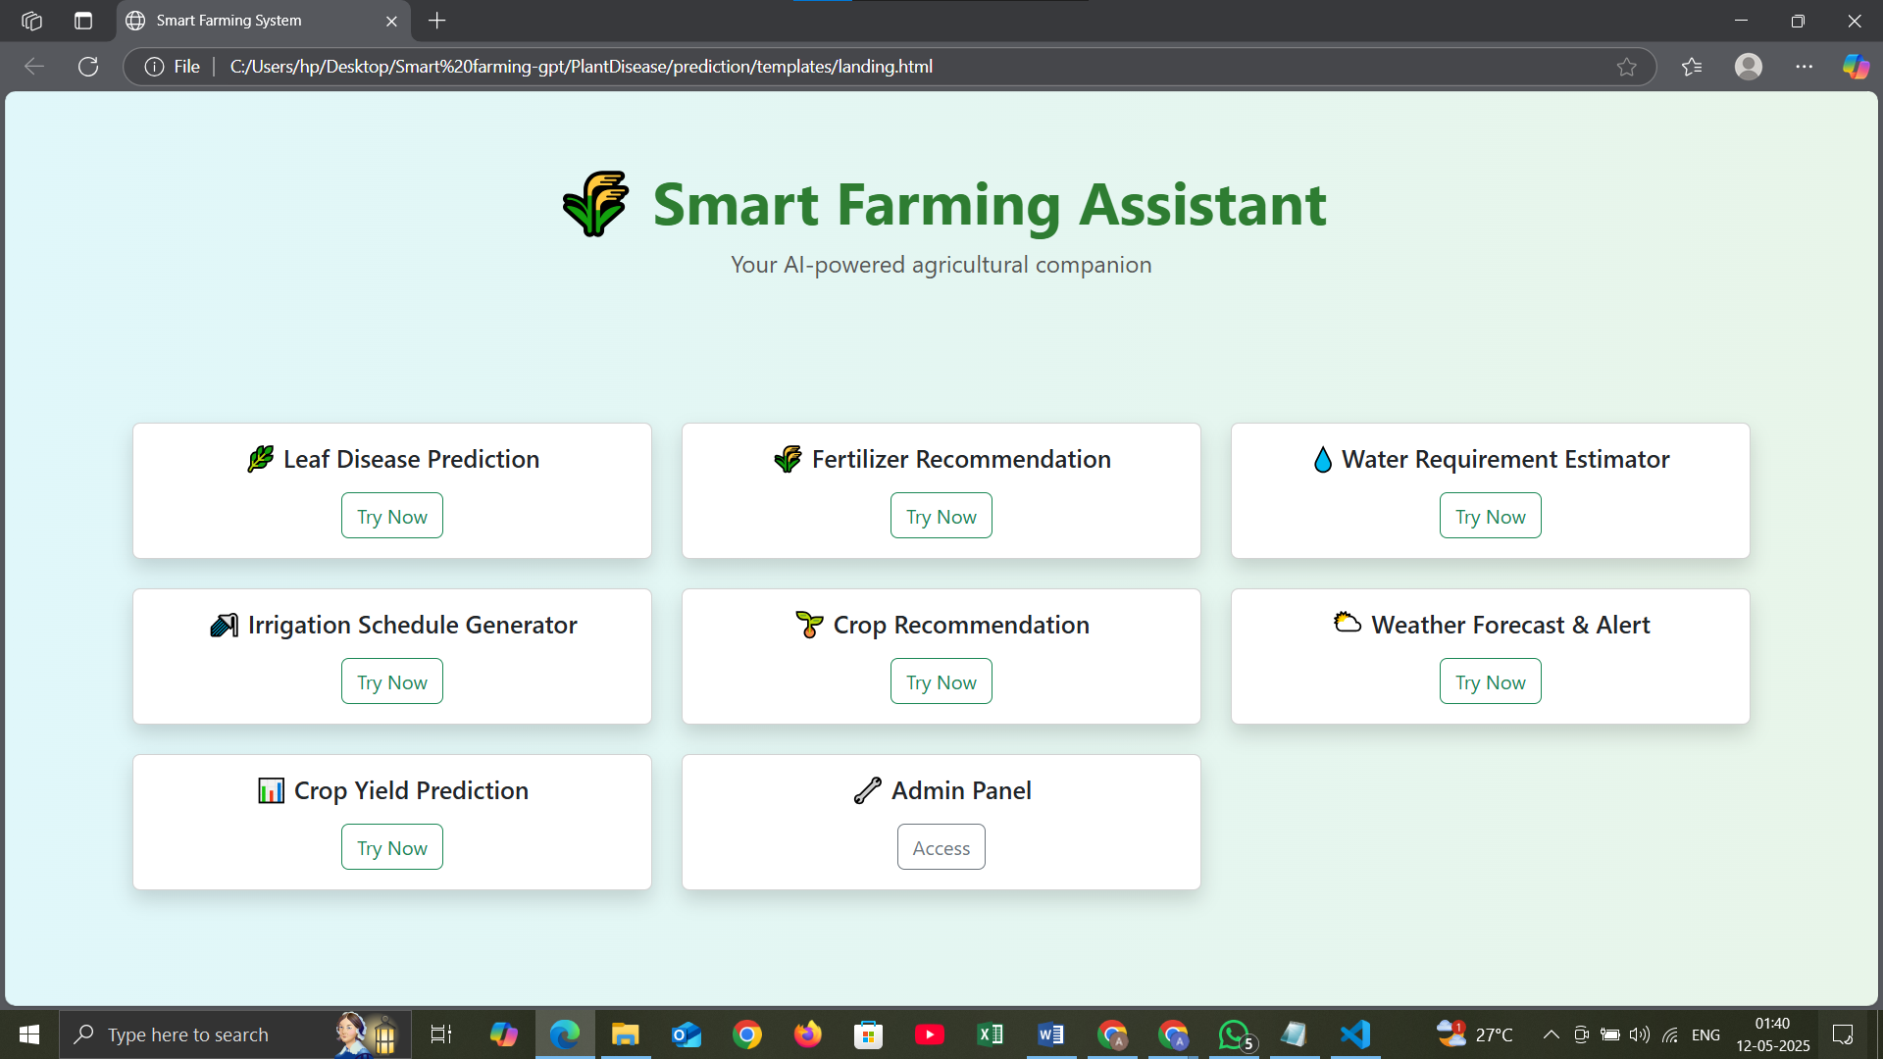

- Document (C:\Users\hp\Desktop\ Smart farming-gpt\PlantDisease\prediction\templates\.prediction.html)
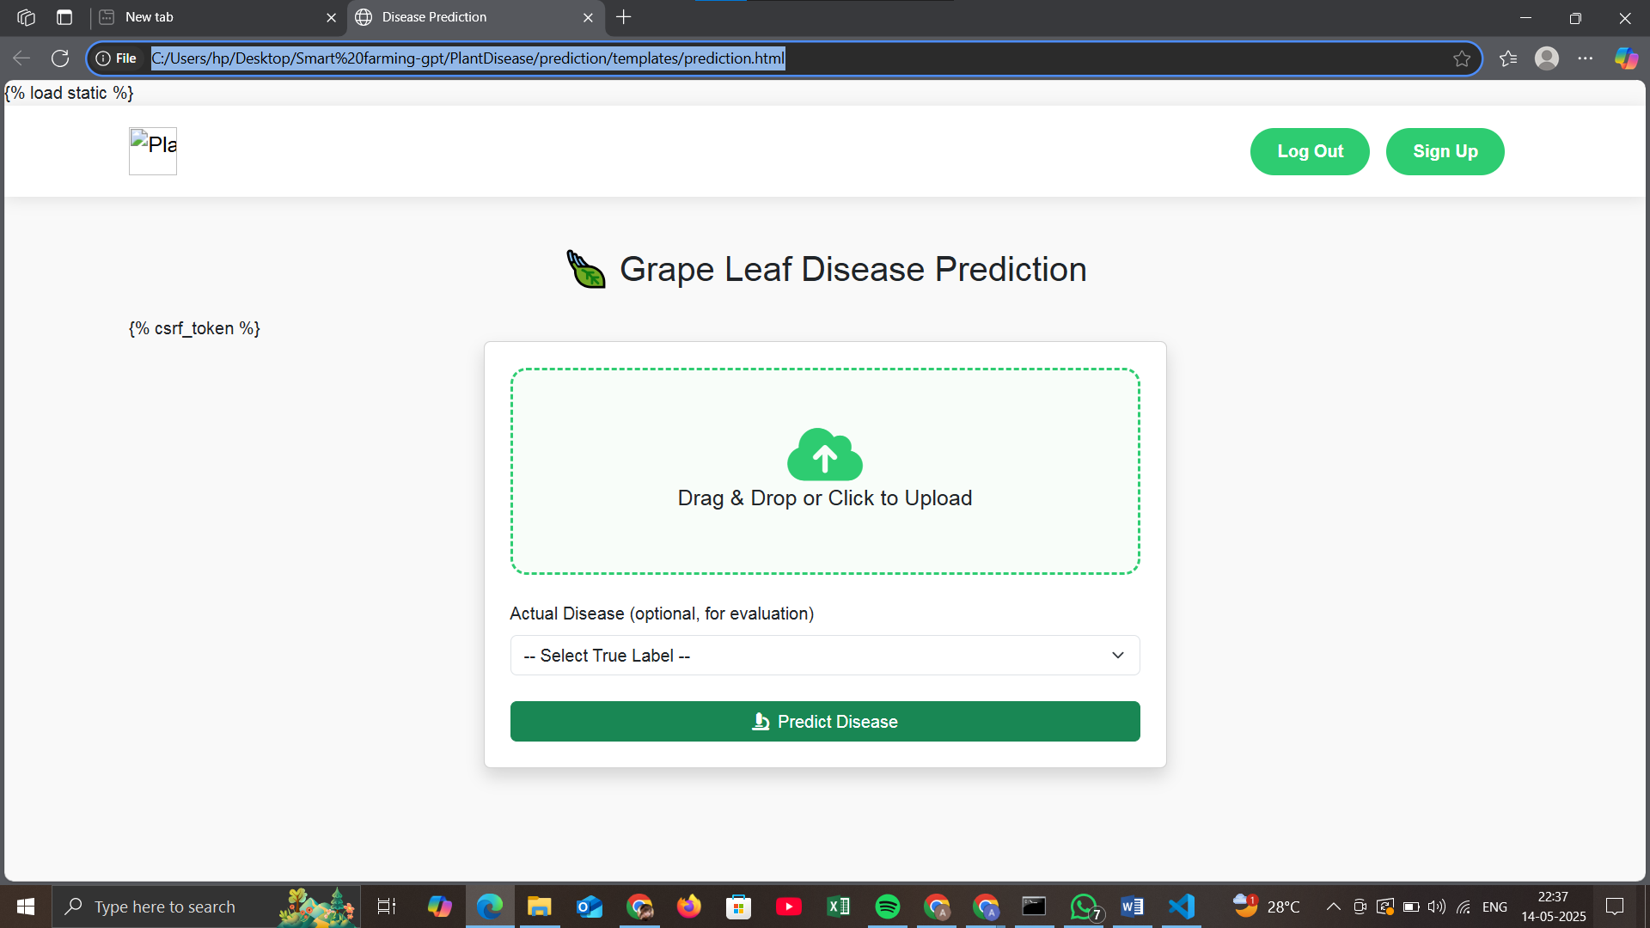

- Document(C:\Users\hp\Desktop\ Smart farming-gpt\PlantDisease\prediction\templates\.result.html)
<!DOCTYPE html>
<html>
<head>
<title>Disease Detection Result</title>
<link href="https://cdn.jsdelivr.net/npm/bootstrap@5.3.0/dist/css/bootstrap.min.css" rel="stylesheet">
<script src="https://cdn.jsdelivr.net/npm/chart.js"></script>
</head>
<body class="bg-light">
<div class="container py-5">
<h2 class="text-center mb-4">🍇 Grape Leaf Disease Prediction</h2>

<!-- Prediction Result -->
<div class="card shadow p-4 mb-4">
<h5 class="text-center text-success">🧪 Diagnosis: <strong>{{ prediction }}</strong></h5>

{% if prob %}
<canvas id="probChart" height="100" class="mt-4"></canvas>
<script>
const ctx = document.getElementById('probChart').getContext('2d');
new Chart(ctx, {
type: 'bar',
data: {
labels: {{ label_names|safe }},
datasets: [{
label: 'Confidence (%)',
data: {{ label_probs|safe }},
backgroundColor: ['#0d6efd', '#dc3545', '#198754', '#ffc107']
}]
},
options: {
scales: {
y: { beginAtZero: true, max: 100 }
}
}
});
</script>
{% endif %}
</div>

<!-- True Label Selection -->
<div class="mb-3">
<label for="true_label" class="form-label">Actual Disease (optional)</label>
<select name="true_label" class="form-select">
<option value="">-- Select True Label --</option>
<option value="Black Rot">Black Rot</option>
<option value="ESCA">ESCA</option>
<option value="Healthy">Healthy</option>
<option value="Leaf Blight">Leaf Blight</option>
</select>
</div>

<!-- Correct/Incorrect Display -->
{% if true_label %}
<div class="alert {% if is_correct %}alert-success{% else %}alert-danger{% endif %} text-center mt-3">
✅ Actual: <strong>{{ true_label }}</strong><br>
{% if is_correct %}✔️ Correct Prediction{% else %}❌ Incorrect Prediction{% endif %}
</div>
{% endif %}

<!-- Cumulative Report -->
{% if report %}
<div class="card mt-4 p-3 shadow">
<h5 class="text-center mb-3">📊 Evaluation Summary (Cumulative)</h5>
<pre class="mb-0">{{ report }}</pre>
</div>
<a href="{% url 'reset_predictions' %}" class="btn btn-danger mt-3">♻️ Reset Evaluation</a>
{% endif %}

<!-- Accuracy Summary -->
{% if accuracy %}
<div class="alert alert-primary text-center mt-4">
📈 Current Evaluation Accuracy: <strong>{{ accuracy }}%</strong>
</div>
{% endif %}

<!-- Per-Class Metrics Chart -->
{% if chart_labels %}
<div class="card mt-4 p-4 shadow">
<h5 class="text-center mb-3">📊 Per-Class Evaluation Metrics</h5>
<canvas id="metricsChart" height="100"></canvas>
</div>
<script>
const ctxMetrics = document.getElementById('metricsChart').getContext('2d');
new Chart(ctxMetrics, {
type: 'bar',
data: {
labels: {{ chart_labels|safe }},
datasets: [
{
label: 'Precision (%)',
data: {{ precision_data|safe }},
backgroundColor: '#0d6efd'
},
{
label: 'Recall (%)',
data: {{ recall_data|safe }},
backgroundColor: '#198754'
},
{
label: 'F1-Score (%)',
data: {{ f1_data|safe }},
backgroundColor: '#ffc107'
}
]
},
options: {
responsive: true,
scales: {
y: {
beginAtZero: true,
max: 100
}
}
}
});
</script>
{% endif %}

<!-- Navigation Buttons -->
<div class="text-center mt-4">
<a href="{% url 'disease_model_report' %}" class="btn btn-outline-info">📊 Show Model Report</a>
<a href="{% url 'prediction' %}" class="btn btn-secondary ms-2">🔁 Predict Another</a>
</div>
</div>
</body>
</html>

- C:\Users\hp\Desktop\Smart farming-gpt\PlantDisease\prediction\templates\disease_model_report
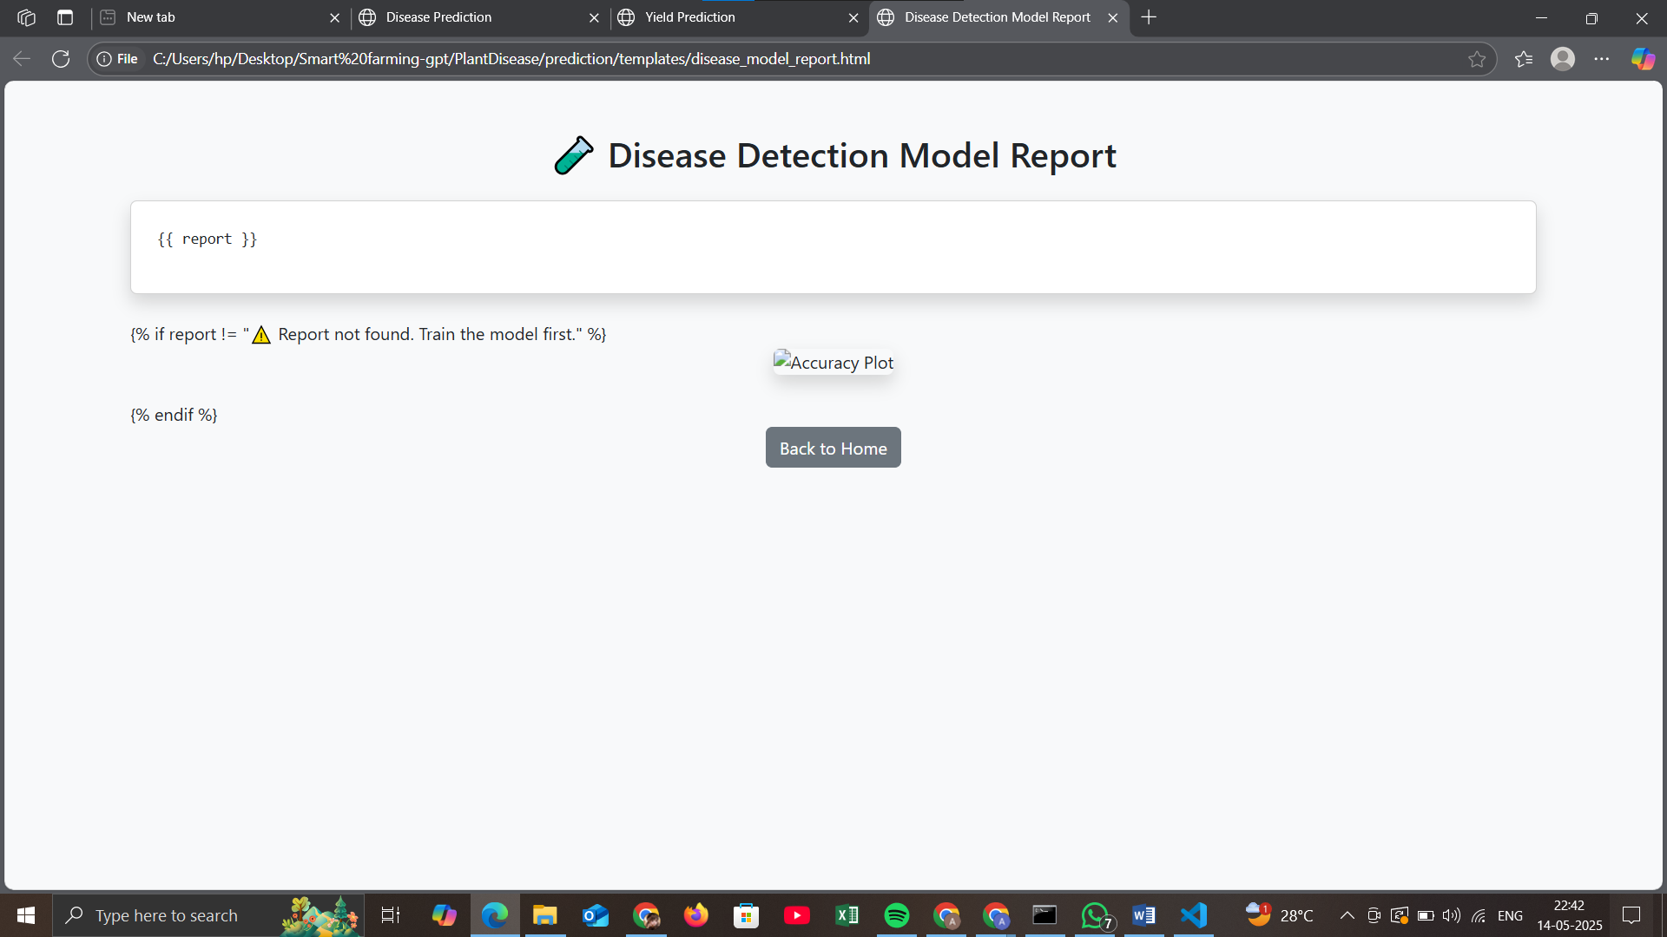
- Yield Prediction Result(C:\Users\hp\Desktop\ Smart farming-gpt\PlantDisease\prediction\templates\yield.html)
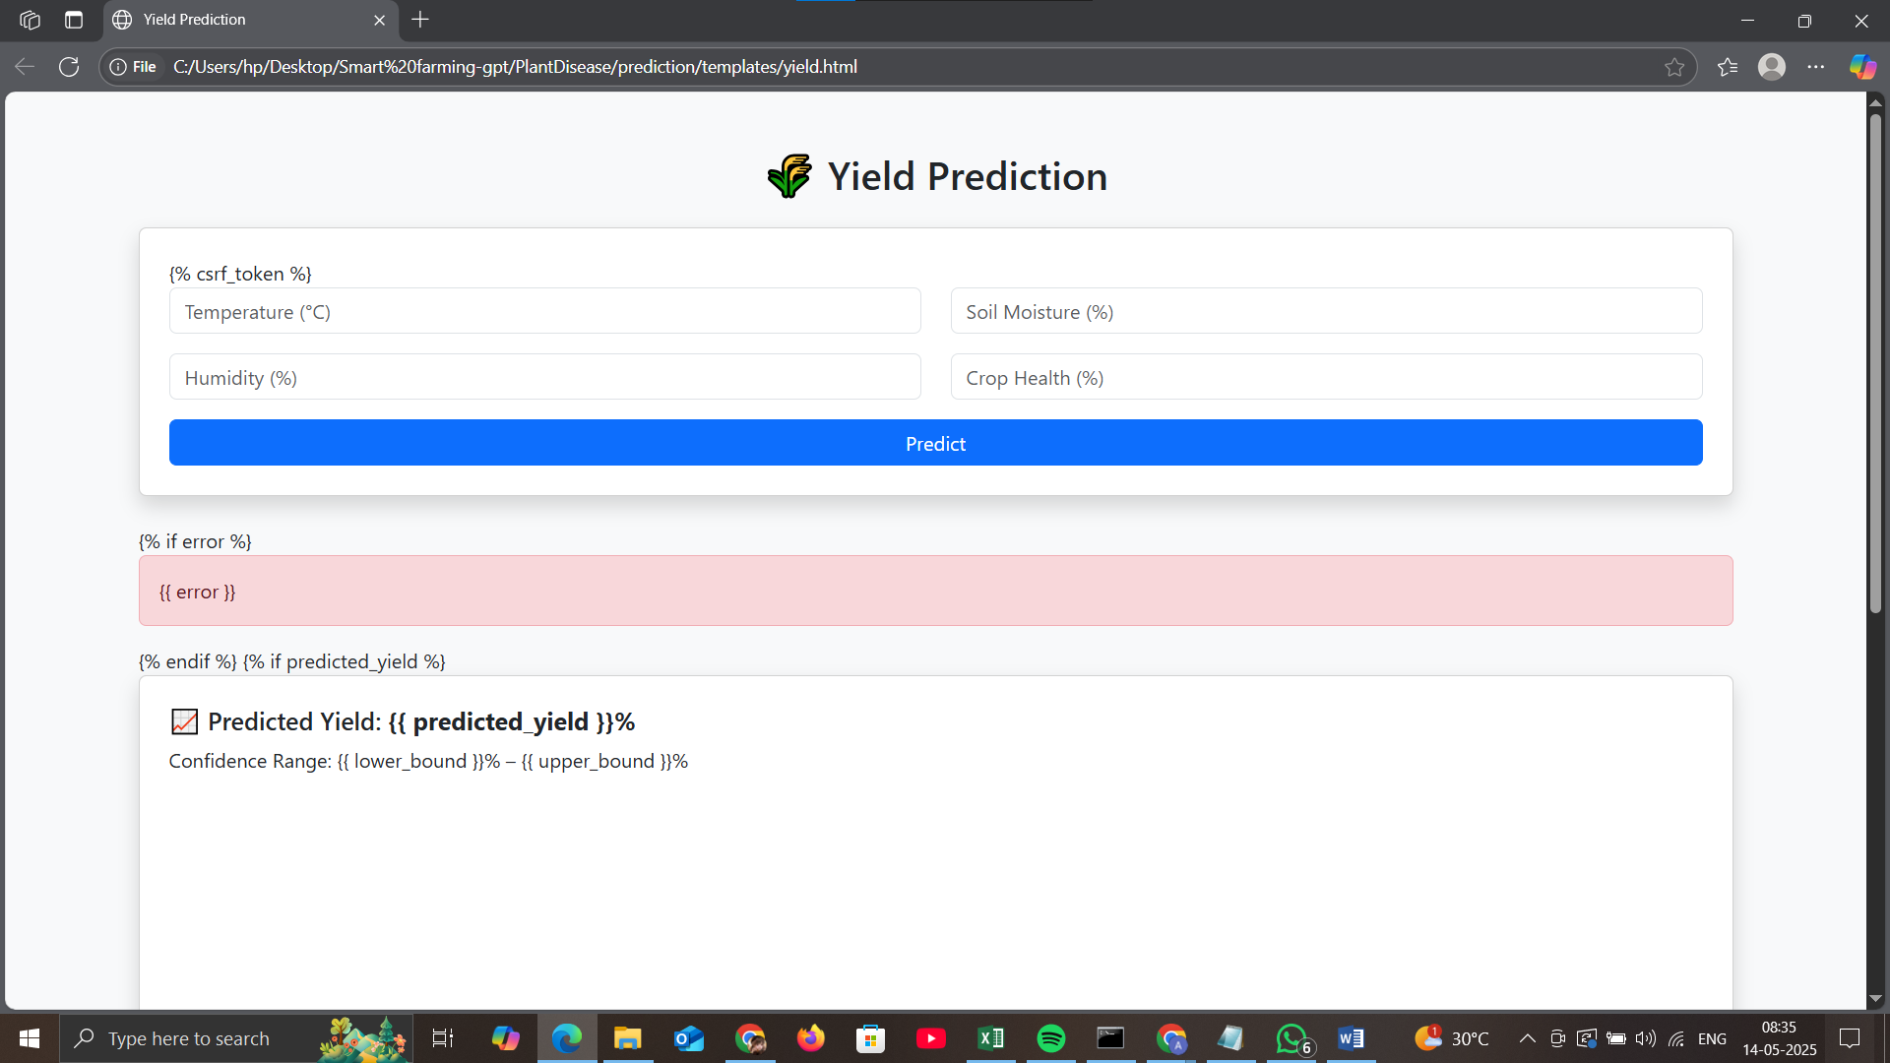
- Crop Recommendation(C:\Users\hp\Desktop\Smart farming -gpt\PlantDisease\prediction\templates\crop.html
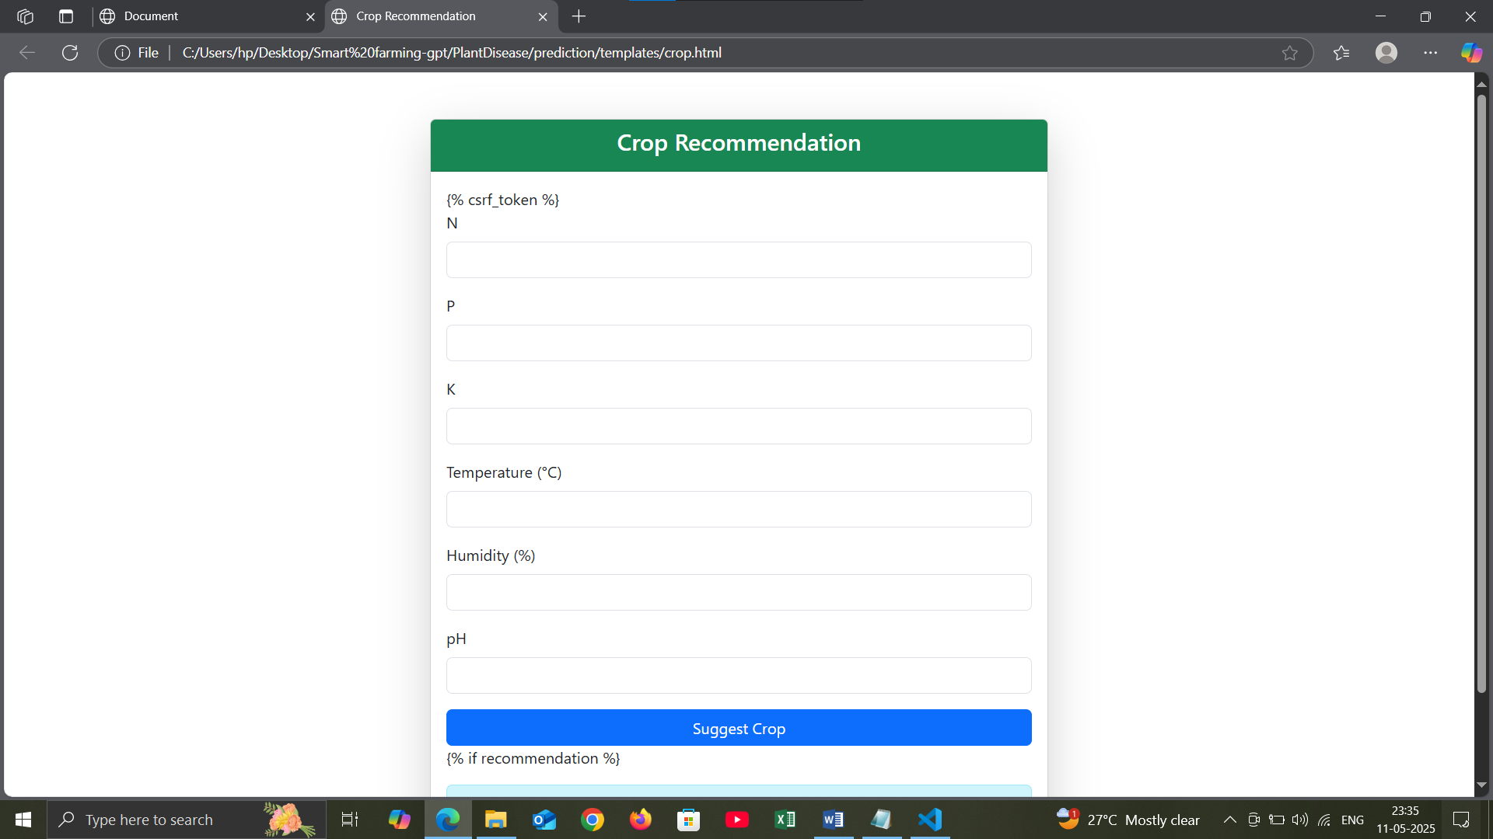
- C:\Users\hp\Desktop\Smart farming-gpt\PlantDisease\prediction\templates
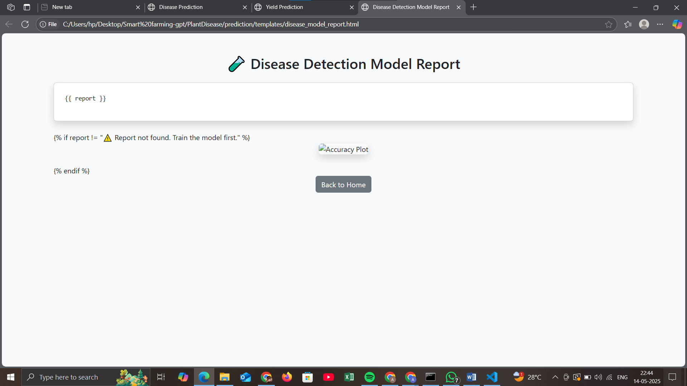

- Fertilizer Recommendation(C:\Users\hp\Desktop\Smart farming-gpt\PlantDisease\prediction\templates\fertilizer.html
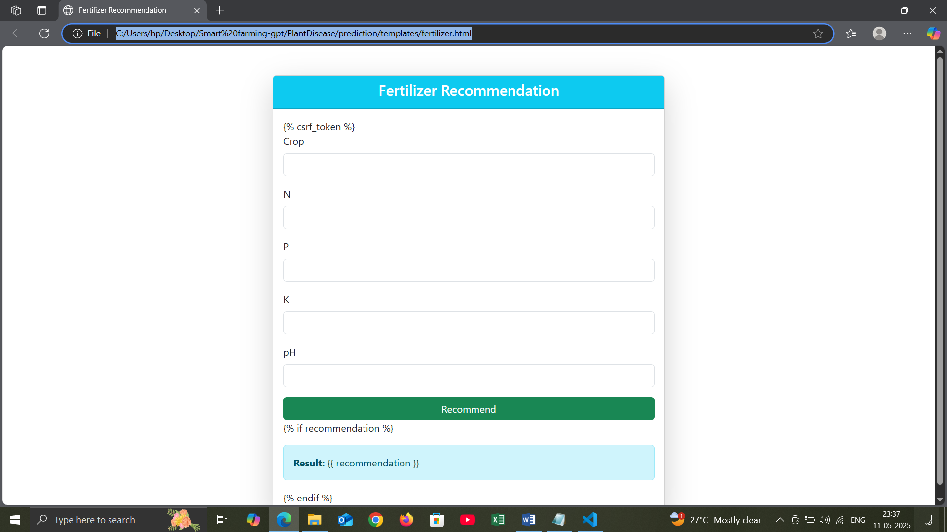
- Irrigation Schedule(C:\Users\hp\Desktop\Smart farming-gpt\PlantDisease\prediction\templates\irrigation.html)
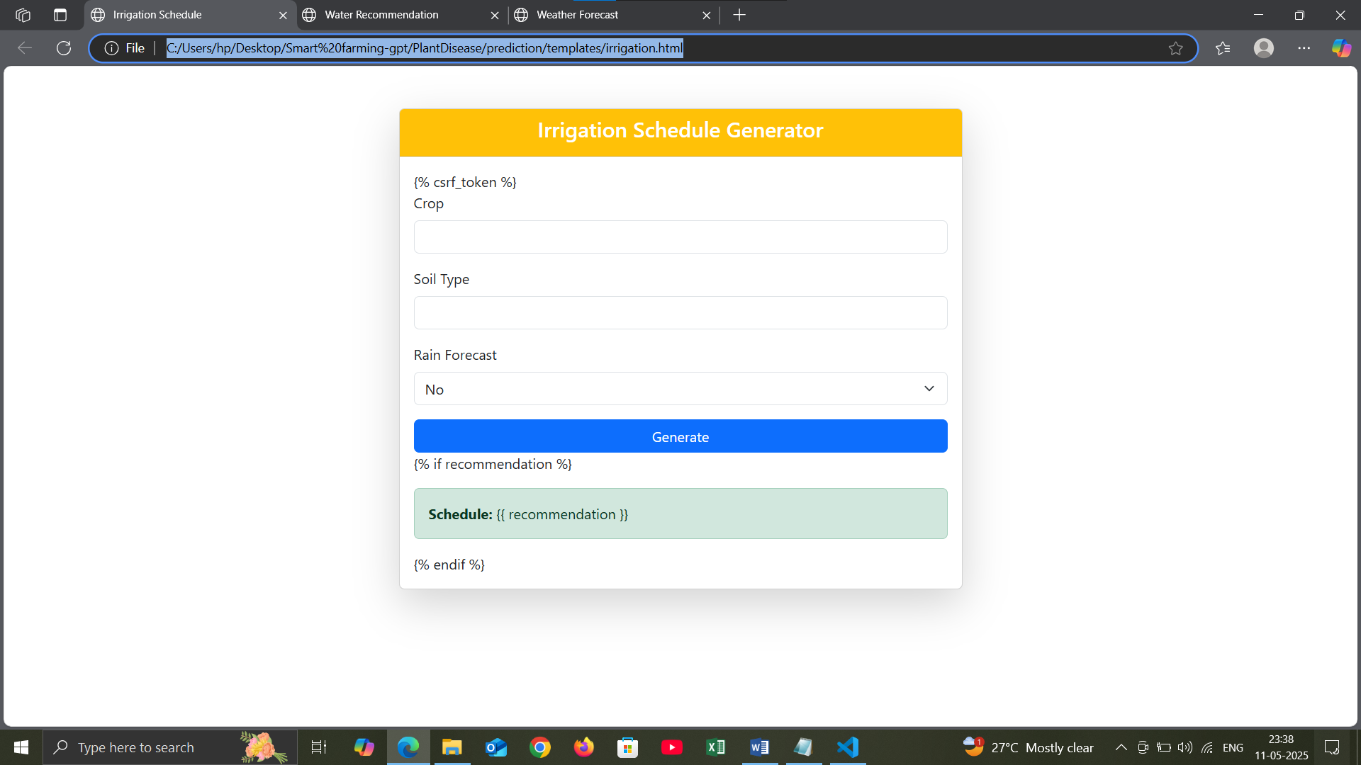
- Water Recommendation(C:\Users\hp\Desktop\Smart farming-gpt\PlantDisease\prediction\templates\water.html)
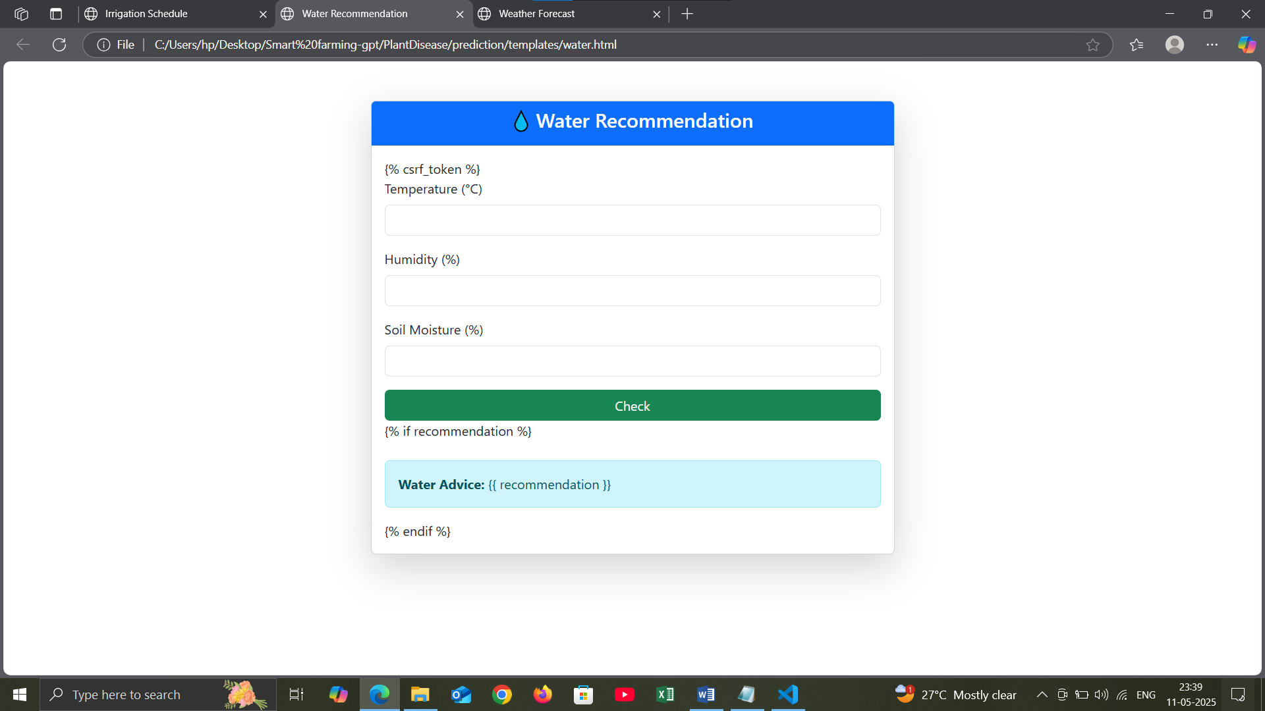

- Weather Forecast(C:\Users\hp\Desktop\Smart farming-gpt\PlantDisease\prediction\templates\weather.html)
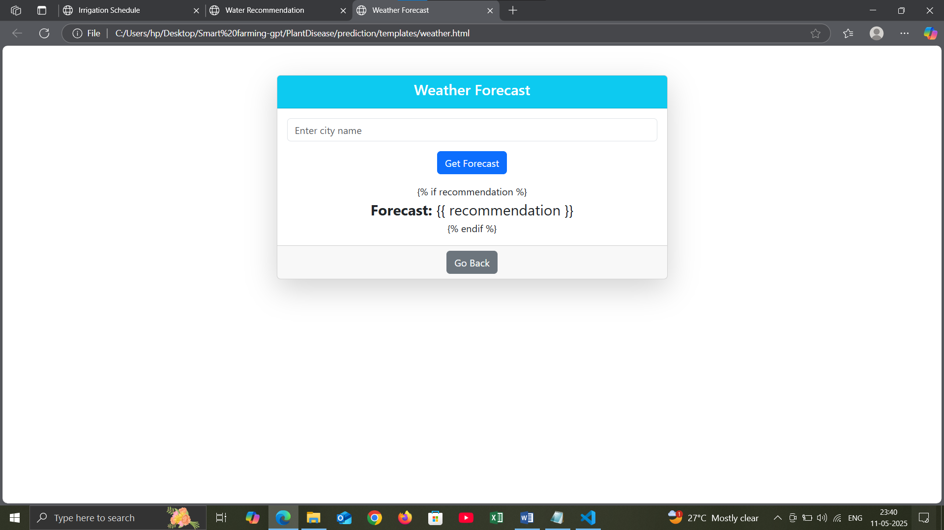
- Yield Model Evaluation Report (C:\Users\hp\Desktop\Smart farming-gpt\PlantDisease\prediction\templates\yield_model_report.html)
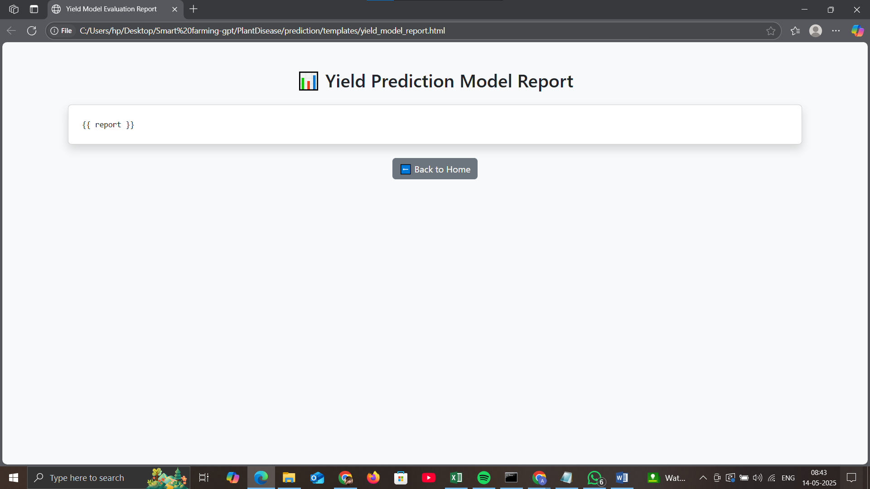
- C:\Users\hp\Desktop\ Smart farming-gpt\PlantDisease\prediction\admin.py
from django.contrib import admin

# Register your models here.
- C:\Users\hp\Desktop\ Smart farming-gpt\PlantDisease\prediction\apps.py
from django.apps import AppConfig

class PredictionConfig(AppConfig):
default_auto_field = 'django.db.models.BigAutoField'
name = 'prediction'
- C:\Users\hp\Desktop\ Smart farming-gpt\PlantDisease\prediction\models.py
from django.db import models

# Create your models here.
- C:\Users\hp\Desktop\ Smart farming-gpt\PlantDisease\prediction\tests.py
from django.test import TestCase

# Create your tests here.

- C:\Users\hp\Desktop\ Smart farming-gpt\PlantDisease\prediction\views.py
from django.shortcuts import render, redirect
import tensorflow as tf
import numpy as np
from django.core.files.storage import default_storage
from django.core.files.base import ContentFile
from PIL import Image
import pandas as pd
import pickle
import requests
import json
from sklearn.metrics import classification_report, accuracy_score
from iot.models import SensorData
from tensorflow.keras.applications.mobilenet_v2 import preprocess_input
from .utils import (
fertilizer_recommender,
water_recommender,
irrigation_schedule,
crop_recommendation,
weather_fetcher
)

# Load models
with open("crop_yield_regression_model.pkl", "rb") as f:
loaded_model = pickle.load(f)
with open("crop_model.pkl", "rb") as f:
crop_model = pickle.load(f)
with open("fertilizer_model.pkl", "rb") as f:
fertilizer_model = pickle.load(f)
with open("water_model.pkl", "rb") as f:
water_model = pickle.load(f)
with open("irrigation_model.pkl", "rb") as f:
irrigation_model = pickle.load(f)
with open("weather_model.pkl", "rb") as f:
weather_model = pickle.load(f)
with open("yield_model.pkl", "rb") as f:
yield_model = pickle.load(f)

model = tf.keras.models.load_model("grape_disease_model.keras")
labels = ['Black Rot', 'ESCA', 'Healthy', 'Leaf Blight']

# ✅ Real-time Disease Prediction + Evaluation
def prediction(request):
result = ""
label_names = []
label_probs = []
is_correct = None
true_label = ""
report_text = ""
chart_labels = []
precision_data = []
recall_data = []
f1_data = []
accuracy = None
image_url = ""

if "pred_log" not in request.session:
request.session["pred_log"] = []

if request.method == "POST" and request.FILES.get("img"):
file = request.FILES["img"]
saved_path = "temp/" + file.name
file_path = default_storage.save(saved_path, ContentFile(file.read()))
image_url = default_storage.url(saved_path)

image = Image.open(default_storage.path(file_path)).convert('RGB')
image = image.resize((224, 224))
image = np.array(image)
image = preprocess_input(image)
image = np.expand_dims(image, axis=0)

predictions = model.predict(image)
predicted_label = labels[np.argmax(predictions)]
result = [{"name": name, "prob": round(prob, 2)} for name, prob in zip(labels, predictions[0] * 100)]
label_names = [r["name"] for r in result]
label_probs = [r["prob"] for r in result]

true_label = request.POST.get("true_label", "")
if true_label:
is_correct = (predicted_label == true_label)
pred_log = request.session.get("pred_log", [])
pred_log.append({"true": true_label, "pred": predicted_label})
request.session["pred_log"] = pred_log

y_true = [item["true"] for item in pred_log]
y_pred = [item["pred"] for item in pred_log]

report_dict = classification_report(y_true, y_pred, output_dict=True, zero_division=0)
report_text = classification_report(y_true, y_pred, output_dict=False, zero_division=0)
accuracy = round(accuracy_score(y_true, y_pred) * 100, 2)

# Prepare chart data
class_metrics = {label: report_dict[label] for label in labels if label in report_dict}
chart_labels = list(class_metrics.keys())
precision_data = [round(class_metrics[l]['precision'] * 100, 2) for l in chart_labels]
recall_data = [round(class_metrics[l]['recall'] * 100, 2) for l in chart_labels]
f1_data = [round(class_metrics[l]['f1-score'] * 100, 2) for l in chart_labels]

return render(request, "result.html", {
"prediction": predicted_label,
"prob": result,
"label_names": label_names,
"label_probs": label_probs,
"image_url": image_url,
"true_label": true_label,
"is_correct": is_correct,
"report": report_text,
"accuracy": accuracy,
"chart_labels": json.dumps(chart_labels),
"precision_data": precision_data,
"recall_data": recall_data,
"f1_data": f1_data,
})

return render(request, "prediction.html", {})

# ✅ Reset evaluation session
def reset_predictions(request):
request.session["pred_log"] = []
return redirect("prediction")

# Yield Prediction View
def yield_prediction_view(request):
prediction = None
true_yield = None
is_correct = None
report = ""
mae_list = []
mse_list = []
r2_list = []
error = ""

if "yield_log" not in request.session:
request.session["yield_log"] = []

if request.method == "POST":
try:
crop = request.POST.get("crop")
sowing_date = request.POST.get("sowing_date")
nitrogen = request.POST.get("N")
phosphorous = request.POST.get("P")
potassium = request.POST.get("K")
ph = request.POST.get("ph")
moisture = request.POST.get("moisture")
temp = request.POST.get("temp")
rainfall = request.POST.get("rainfall")
true_yield = request.POST.get("true_yield")

# Check required fields
required_fields = [crop, sowing_date, nitrogen, phosphorous, potassium, ph, moisture, temp, rainfall]
if not all(required_fields):
raise ValueError("All fields except actual yield are required.")

# Convert to correct types
nitrogen = int(nitrogen)
phosphorous = int(phosphorous)
potassium = int(potassium)
ph = float(ph)
moisture = float(moisture)
temp = float(temp)
rainfall = float(rainfall)
day_of_year = pd.to_datetime(sowing_date).dayofyear

input_df = pd.DataFrame([{
"Crop": crop,
"N": nitrogen,
"P": phosphorous,
"K": potassium,
"pH": ph,
"Temperature": temp,
"Rainfall": rainfall,
"Soil_Moisture": moisture,
"Sowing_DayOfYear": day_of_year
}])

prediction = round(yield_model.predict(input_df)[0], 2)

# Evaluation
if true_yield:
true_yield = float(true_yield)
log = request.session["yield_log"]
log.append({"true": true_yield, "pred": prediction})
request.session["yield_log"] = log

y_true = [x["true"] for x in log]
y_pred = [x["pred"] for x in log]

from sklearn.metrics import mean_absolute_error, mean_squared_error, r2_score

mae = mean_absolute_error(y_true, y_pred)
mse = mean_squared_error(y_true, y_pred)
r2 = r2_score(y_true, y_pred)

mae_list = [round(mae, 2)]
mse_list = [round(mse, 2)]
r2_list = [round(r2 * 100, 2)]
is_correct = abs(prediction - true_yield) < 200

report = f"MAE: {mae:.2f}, MSE: {mse:.2f}, R²: {r2:.2f}"

except Exception as e:
error = f"⚠️ Error: {e}"

return render(request, "yield.html", {
"prediction": prediction,
"true_yield": true_yield,
"is_correct": is_correct,
"report": report,
"mae_list": mae_list,
"mse_list": mse_list,
"r2_list": r2_list,
"error": error
})

def reset_yield_log(request):
request.session["yield_log"] = []
return redirect("yield_predictions")

# Fertilizer Recommendation View
def fertilizer_view(request):
recommendation = ""
true_label = ""
is_correct = None
accuracy = None
report_text = ""
chart_labels = []
precision_data = []
recall_data = []
f1_data = []
error = ""

if "fertilizer_log" not in request.session:
request.session["fertilizer_log"] = []

if request.method == "POST":
try:
crop = request.POST.get("crop")
N = int(request.POST.get("N"))
P = int(request.POST.get("P"))
K = int(request.POST.get("K"))
pH = float(request.POST.get("pH"))
temp = float(request.POST.get("temp", 25))
rain = float(request.POST.get("rain", 100))
true_label = request.POST.get("true_label")

input_df = pd.DataFrame([{
"Crop": crop,
"N": N,
"P": P,
"K": K,
"pH": pH,
"Temperature": temp,
"Rainfall": rain
}])

prediction = fertilizer_model.predict(input_df)[0]
recommendation = prediction

if true_label:
fertilizer_log = request.session["fertilizer_log"]
fertilizer_log.append({"true": true_label, "pred": prediction})
request.session["fertilizer_log"] = fertilizer_log

from sklearn.metrics import classification_report, accuracy_score
y_true = [x["true"] for x in fertilizer_log]
y_pred = [x["pred"] for x in fertilizer_log]

from sklearn.metrics import classification_report
report = classification_report(y_true, y_pred, output_dict=True)
report_text = classification_report(y_true, y_pred, output_dict=False)
accuracy = round(accuracy_score(y_true, y_pred) * 100, 2)

chart_labels = list(report.keys())[:-3]
precision_data = [round(report[l]['precision'] * 100, 2) for l in chart_labels]
recall_data = [round(report[l]['recall'] * 100, 2) for l in chart_labels]
f1_data = [round(report[l]['f1-score'] * 100, 2) for l in chart_labels]

is_correct = (prediction == true_label)

except Exception as e:
error = f"⚠️ Error: {e}"

return render(request, "fertilizer.html", {
"recommendation": recommendation,
"true_label": true_label,
"is_correct": is_correct,
"accuracy": accuracy,
"report": report_text,
"chart_labels": json.dumps(chart_labels),
"precision_data": precision_data,
"recall_data": recall_data,
"f1_data": f1_data,
"error": error,
})
def reset_fertilizer_log(request):
request.session["fertilizer_log"] = []
return redirect("fertilizer")

# Water Recommendation View
def water_view(request):
result = ""
true_label = ""
is_correct = None
accuracy = None
report_text = ""
chart_labels = []
precision_data = []
recall_data = []
f1_data = []
error = ""

if "water_log" not in request.session:
request.session["water_log"] = []

if request.method == "POST":
try:
crop = request.POST.get("crop")
stage = request.POST.get("stage")
temp = float(request.POST.get("temp"))
humidity = float(request.POST.get("humidity"))
rain = float(request.POST.get("rain"))
soil = request.POST.get("soil")
true_label = request.POST.get("true_label")

input_df = pd.DataFrame([{
"Crop": crop,
"Growth_Stage": stage,
"Temperature": temp,
"Humidity": humidity,
"Rainfall": rain,
"Soil_Type": soil
}])

prediction = water_model.predict(input_df)[0]
result = prediction

if true_label:
log = request.session["water_log"]
log.append({"true": true_label, "pred": prediction})
request.session["water_log"] = log

from sklearn.metrics import classification_report, accuracy_score
y_true = [x["true"] for x in log]
y_pred = [x["pred"] for x in log]

report = classification_report(y_true, y_pred, output_dict=True)
report_text = classification_report(y_true, y_pred, output_dict=False)
accuracy = round(accuracy_score(y_true, y_pred) * 100, 2)

chart_labels = list(report.keys())[:-3]
precision_data = [round(report[l]['precision'] * 100, 2) for l in chart_labels]
recall_data = [round(report[l]['recall'] * 100, 2) for l in chart_labels]
f1_data = [round(report[l]['f1-score'] * 100, 2) for l in chart_labels]

is_correct = (prediction == true_label)

except Exception as e:
error = f"⚠️ Error: {e}"

return render(request, "water.html", {
"recommendation": result,
"true_label": true_label,
"is_correct": is_correct,
"accuracy": accuracy,
"report": report_text,
"chart_labels": json.dumps(chart_labels),
"precision_data": precision_data,
"recall_data": recall_data,
"f1_data": f1_data,
"error": error,
})
def reset_water_log(request):
request.session["water_log"] = []
return redirect("water")

# Irrigation Schedule View
def irrigation_view(request):
recommendation = ""
true_label = ""
is_correct = None
accuracy = None
report_text = ""
chart_labels = []
precision_data = []
recall_data = []
f1_data = []
error = ""

if "irrigation_log" not in request.session:
request.session["irrigation_log"] = []

if request.method == "POST":
try:
crop = request.POST.get("crop")
soil = request.POST.get("soil")
whc = {"sandy": "Low", "loamy": "Medium", "clay": "High"}[soil]
temp = float(request.POST.get("temp"))
rain = float(request.POST.get("rain"))
stage = request.POST.get("stage")
irrigation_type = request.POST.get("irrigation_type")
true_label = request.POST.get("true_label")

input_df = pd.DataFrame([{
"Crop": crop,
"Soil_Type": soil,
"Water_Holding_Capacity": whc,
"Temperature": temp,
"Rainfall": rain,
"Growth_Stage": stage,
"Irrigation_Type": irrigation_type
}])

prediction = irrigation_model.predict(input_df)[0]
recommendation = prediction

if true_label:
log = request.session["irrigation_log"]
log.append({"true": true_label, "pred": prediction})
request.session["irrigation_log"] = log

from sklearn.metrics import classification_report, accuracy_score
y_true = [x["true"] for x in log]
y_pred = [x["pred"] for x in log]

report = classification_report(y_true, y_pred, output_dict=True)
report_text = classification_report(y_true, y_pred, output_dict=False)
accuracy = round(accuracy_score(y_true, y_pred) * 100, 2)

chart_labels = list(report.keys())[:-3]
precision_data = [round(report[l]['precision'] * 100, 2) for l in chart_labels]
recall_data = [round(report[l]['recall'] * 100, 2) for l in chart_labels]
f1_data = [round(report[l]['f1-score'] * 100, 2) for l in chart_labels]

is_correct = (prediction == true_label)

except Exception as e:
error = f"⚠️ Error: {e}"

return render(request, "irrigation.html", {
"recommendation": recommendation,
"true_label": true_label,
"is_correct": is_correct,
"accuracy": accuracy,
"report": report_text,
"chart_labels": json.dumps(chart_labels),
"precision_data": precision_data,
"recall_data": recall_data,
"f1_data": f1_data,
"error": error,
})
def reset_irrigation_log(request):
request.session["irrigation_log"] = []
return redirect("irrigation")

# Crop Recommendation View
def crop_view(request):
recommendation = ""
error = ""
if request.method == "POST":
try:
N = int(request.POST.get("N"))
P = int(request.POST.get("P"))
K = int(request.POST.get("K"))
temp = float(request.POST.get("temp"))
humidity = float(request.POST.get("humidity"))
pH = float(request.POST.get("pH"))
soil = request.POST.get("soil")

input_df = pd.DataFrame([{
"N": N,
"P": P,
"K": K,
"Temperature": temp,
"Humidity": humidity,
"pH": pH,
"Soil": soil
}])

prediction = crop_model.predict(input_df)[0]
recommendation = prediction

except Exception as e:
error = f"⚠️ Invalid input: {e}"

return render(request, "crop.html", {
"recommendation": recommendation,
"error": error
})

# Weather Forecast View
def weather_view(request):
recommendation = ""
true_label = ""
is_correct = None
accuracy = None
report_text = ""
chart_labels = []
precision_data = []
recall_data = []
f1_data = []
error = ""

if "weather_log" not in request.session:
request.session["weather_log"] = []

if request.method == "POST":
try:
lat = float(request.POST.get("lat"))
lon = float(request.POST.get("lon"))
temp = float(request.POST.get("temp"))
humidity = float(request.POST.get("humidity"))
pressure = float(request.POST.get("pressure"))
wind_speed = float(request.POST.get("wind_speed"))
wind_dir = request.POST.get("wind_dir")
rainfall = float(request.POST.get("rainfall"))
true_label = request.POST.get("true_label")

input_df = pd.DataFrame([{
"Latitude": lat,
"Longitude": lon,
"Temperature": temp,
"Humidity": humidity,
"Pressure": pressure,
"Wind_Speed": wind_speed,
"Wind_Direction": wind_dir,
"Rainfall": rainfall
}])

prediction = weather_model.predict(input_df)[0]
recommendation = prediction

if true_label:
log = request.session["weather_log"]
log.append({"true": true_label, "pred": prediction})
request.session["weather_log"] = log

from sklearn.metrics import classification_report, accuracy_score
y_true = [x["true"] for x in log]
y_pred = [x["pred"] for x in log]

report = classification_report(y_true, y_pred, output_dict=True)
report_text = classification_report(y_true, y_pred, output_dict=False)
accuracy = round(accuracy_score(y_true, y_pred) * 100, 2)

chart_labels = list(report.keys())[:-3]
precision_data = [round(report[l]['precision'] * 100, 2) for l in chart_labels]
recall_data = [round(report[l]['recall'] * 100, 2) for l in chart_labels]
f1_data = [round(report[l]['f1-score'] * 100, 2) for l in chart_labels]

is_correct = (prediction == true_label)

except Exception as e:
error = f"⚠️ Error: {e}"

return render(request, "weather.html", {
"recommendation": recommendation,
"true_label": true_label,
"is_correct": is_correct,
"accuracy": accuracy,
"report": report_text,
"chart_labels": json.dumps(chart_labels),
"precision_data": precision_data,
"recall_data": recall_data,
"f1_data": f1_data,
"error": error,
})
def reset_weather_log(request):
request.session["weather_log"] = []
return redirect("weather")

# Home View
def home(request):
return render(request, "landing.html", {})

def geo_dashboard(request):
context = {}
if request.method == "POST":
city = request.POST.get("city")
lat = request.POST.get("latitude")
lon = request.POST.get("longitude")

if city:
url = f"https://api.openweathermap.org/data/2.5/weather?q={city}&appid=5478b4526d575f15ee1aafd72ccd5424&units=metric"
elif lat and lon:
url = f"https://api.openweathermap.org/data/2.5/weather?lat={lat}&lon={lon}&appid=5478b4526d575f15ee1aafd72ccd5424&units=metric"
else:
context['error'] = "Please enter a city or coordinates."
return render(request, "geo/geo_dashboard.html", context)

try:
res = requests.get(url)
data = res.json()

context["weather"] = {
"temperature": data["main"]["temp"],
"humidity": data["main"]["humidity"],
"wind": data["wind"]["speed"],
"description": data["weather"][0]["description"]
}

context["soil"] = {
"type": "Loamy",
"pH": round(6.2 + float(data["main"]["humidity"]) / 100, 1),
"moisture": round(30 + float(data["main"]["temp"]) / 3, 1)
}

request.session['geo_sensor'] = {
"temperature": context["weather"]["temperature"],
"humidity": context["weather"]["humidity"],
"soil_moisture": context["soil"]["moisture"],
"crop_health": round(60 + context["weather"]["temperature"] / 2, 1)
}

except Exception as e:
context['error'] = f"Error fetching data: {e}"

return render(request, "geo/geo_dashboard.html", context)

# Model Report Views
def yield_model_report_view(request):
report = ""
try:
with open("yield_model_report.txt", "r") as file:
report = file.read()
except FileNotFoundError:
report = "⚠️ Evaluation report not found. Please run the training script first."
return render(request, "yield_model_report.html", {"report": report})

def crop_model_report_view(request):
report = ""
try:
with open("crop_model_report.txt", "r") as file:
report = file.read()
except:
report = "⚠️ Report not found. Please train the model first."
return render(request, "crop_model_report.html", {"report": report})

def disease_model_report_view(request):
report = ""
try:
with open("disease_model_report.txt", "r") as f:
report = f.read()
except:
report = "⚠️ Report not found. Train the model first."

return render(request, "disease_model_report.html", {"report": report})

- C:\Users\hp\Desktop\Smart farming-gpt\PlantDisease\crop
_recommendation_dataset.xlsx
- C:\Users\hp\Desktop\Smart farming-gpt\PlantDisease\generate_crop_dataset.py
import pandas as pd
import numpy as np
np.random.seed(42)
num_samples = 1000
# Feature generation
N = np.random.randint(0, 140, num_samples)
P = np.random.randint(5, 120, num_samples)
K = np.random.randint(5, 200, num_samples)
temp = np.random.uniform(10, 40, num_samples)
humidity = np.random.uniform(20, 90, num_samples)
pH = np.random.uniform(4.5, 9.5, num_samples)
# Add soil type (categorical)
soil_types = ['clay', 'sandy', 'loam', 'black', 'red', 'alluvial']
soil = np.random.choice(soil_types, num_samples)
# Crop assignment logic using all features
def choose_crop(n, p, k, temp, humidity, pH, soil_type):
if soil_type == "clay" and 25 <= temp <= 35 and humidity >= 60 and pH >= 5.5 and n > 80:
return "Rice"
elif soil_type == "loam" and 20 <= temp <= 30 and humidity < 60 and pH >= 6.0 and n < 50 and k < 100:
return "Wheat"
elif soil_type == "black" and 20 <= temp <= 27 and 60 <= humidity <= 80 and 5.0 <= pH <= 6.5 and p > 50:
return "Potato"
elif soil_type == "alluvial" and 28 <= temp <= 38 and humidity >= 50 and 6.0 <= pH <= 7.5 and k > 130:
return "Sugarcane"
elif soil_type == "red" and 22 <= temp <= 32 and 40 <= humidity <= 70 and 5.5 <= pH <= 7.5 and n >= 50 and p >= 50:
return "Maize"
elif soil_type == "sandy" and 20 <= temp <= 30 and humidity > 65 and pH < 6.0 and p < 40:
return "Groundnut"
else:
return "Cotton"
# Apply crop logic to all rows
crop = [choose_crop(N[i], P[i], K[i], temp[i], humidity[i], pH[i], soil[i]) for i in range(num_samples)]

# Build the dataset
df = pd.DataFrame({
"N": N,
"P": P,
"K": K,
"Temperature": temp,
"Humidity": humidity,
"pH": pH,
"Soil": soil,
"Crop": crop
})

# Save to CSV
df.to_csv("crop_recommendation_dataset.csv", index=False)
print("✅ Advanced crop dataset with soil type saved.")

- C:\Users\hp\Desktop\Smart farming-gpt\PlantDisease\generate_yield_dataset.py
import pandas as pd
import numpy as np

np.random.seed(42)
num_samples = 1000

# Generate features with realistic variation
temperature = np.random.uniform(15, 40, num_samples) # °C
humidity = np.random.uniform(30, 90, num_samples) # %
soil_moisture = np.random.uniform(5, 60, num_samples) # %
crop_health = np.clip(np.random.normal(humidity * 0.4 + soil_moisture * 0.6, 10), 30, 100) # %

# Generate more diverse, non-linear yield values
yield_percentage = (
0.3 * temperature +
0.4 * soil_moisture +
0.2 * humidity +
0.1 * crop_health +
np.random.normal(0, 5, num_samples) # add noise
)

yield_percentage = np.clip(yield_percentage, 25, 90)

# Assemble into a DataFrame
df = pd.DataFrame({
"Temperature (°C)": temperature,
"Moisture (%)": soil_moisture,
"Humidity (%)": humidity,
"Crop Health (%)": crop_health,
"Yield (%)": yield_percentage
})

# Save to CSV
df.to_csv("improved_crop_yield_dataset.csv", index=False)
print("✅ Dataset created: improved_crop_yield_dataset.csv")

- C:\Users\hp\Desktop\Smart farming-gpt\PlantDisease\crop_yield_dataset.xlsx

- C:\Users\hp\Desktop\ Smart farming-gpt\PlantDisease\manage.py
#!/usr/bin/env python
"""Django's command-line utility for administrative tasks."""
import os
import sys

def main():
"""Run administrative tasks."""
os.environ.setdefault('DJANGO_SETTINGS_MODULE', 'PlantDisease.settings')
try:
from django.core.management import execute_from_command_line
except ImportError as exc:
raise ImportError(
"Couldn't import Django. Are you sure it's installed and "
"available on your PYTHONPATH environment variable? Did you "
"forget to activate a virtual environment?"
) from exc
execute_from_command_line(sys.argv)

if __name__ == '__main__':
main()

- C:\Users\hp\Desktop\Smart farming-gpt\PlantDisease\train_crop_model.py
import pandas as pd
import pickle
from sklearn.ensemble import RandomForestClassifier
from sklearn.model_selection import train_test_split
from sklearn.metrics import classification_report, accuracy_score
from sklearn.preprocessing import OneHotEncoder
from sklearn.compose import ColumnTransformer
from sklearn.pipeline import Pipeline

# Load the dataset
df = pd.read_csv("crop_recommendation_dataset.csv")

# Separate features and target
X = df.drop(columns=["Crop"])
y = df["Crop"]

# Define categorical and numeric columns
categorical_features = ["Soil"]
numeric_features = [col for col in X.columns if col not in categorical_features]

# Build preprocessing pipeline
preprocessor = ColumnTransformer(
transformers=[
("cat", OneHotEncoder(handle_unknown="ignore"), categorical_features)
],
remainder='passthrough' # numeric features stay as-is
)

# Full pipeline: preprocess + model
pipeline = Pipeline([
("preprocessor", preprocessor),
("classifier", RandomForestClassifier(n_estimators=100, random_state=42))
])

# Split data
X_train, X_test, y_train, y_test = train_test_split(X, y, test_size=0.2, random_state=42)

# Train model
pipeline.fit(X_train, y_train)

# Predict and evaluate
y_pred = pipeline.predict(X_test)
accuracy = accuracy_score(y_test, y_pred)
report = classification_report(y_test, y_pred)

# Save model
with open("crop_model.pkl", "wb") as f:
pickle.dump(pipeline, f)

# Save report
with open("crop_model_report.txt", "w") as f:
f.write(f"Accuracy: {accuracy:.2f}\n\n")
f.write(report)

print("✅ Crop recommendation model trained and saved.")

- C:\Users\hp\Desktop\Smart farming-gpt\PlantDisease\train_yield_model.py
import pandas as pd
import pickle
from sklearn.ensemble import RandomForestRegressor
from sklearn.model_selection import train_test_split
from sklearn.metrics import r2_score, mean_absolute_error, mean_squared_error
import numpy as np

df = pd.read_csv("improved_crop_yield_dataset.csv")
X = df.drop(columns=["Yield (%)"])
y = df["Yield (%)"]

X_train, X_test, y_train, y_test = train_test_split(X, y, test_size=0.2, random_state=42)

model = RandomForestRegressor(n_estimators=150, random_state=42)
model.fit(X_train, y_train)

y_pred = model.predict(X_test)
r2 = r2_score(y_test, y_pred)
mae = mean_absolute_error(y_test, y_pred)
mse = mean_squared_error(y_test, y_pred)

with open("crop_yield_regression_model.pkl", "wb") as f:
pickle.dump(model, f)

with open("yield_model_report.txt", "w") as f:
f.write(f"R² Score: {r2:.3f}\n")
f.write(f"MAE: {mae:.2f}\n")
f.write(f"MSE: {mse:.2f}\n")

print("✅ Model trained and saved.")

- C:\Users\hp\Desktop\Smart farming-gpt\PlantDisease\yield_model_report.txt
R² Score: 0.699
MAE: 3.99
MSE: 26.30
- C:\Users\hp\Desktop\Smart farming-gpt\PlantDisease\crop_model_report.txt

Accuracy: 0.98

precision recall f1-score support

Cotton 0.98 1.00 0.99 196
Groundnut 0.00 0.00 0.00 1
Maize 0.00 0.00 0.00 1
Rice 0.00 0.00 0.00 1
Wheat 0.00 0.00 0.00 1

accuracy 0.98 200
macro avg 0.20 0.20 0.20 200
weighted avg 0.96 0.98 0.97 200

- C:\Users\hp\Desktop\Smart farming-gpt\PlantDisease\disease_model_report.txt
precision recall f1-score support

Black Rot 0.95 1.00 0.97 472
ESCA 1.00 0.95 0.97 480
Healthy 1.00 1.00 1.00 423
Leaf Blight 1.00 1.00 1.00 430

accuracy 0.99 1805
macro avg 0.99 0.99 0.99 1805
weighted avg 0.99 0.99 0.99 1805
- C:\Users\hp\Desktop\Smart farming-gpt\PlantDisease\train_yield_model.py
import tensorflow as tf
from tensorflow.keras.preprocessing.image import ImageDataGenerator
from tensorflow.keras.applications import MobileNetV2
from tensorflow.keras import layers, models
import matplotlib.pyplot as plt
from sklearn.metrics import classification_report, confusion_matrix
import numpy as np
import os

# Paths
train_dir = "dataset/train"
test_dir = "dataset/test"

# Image settings
IMG_SIZE = 224
BATCH_SIZE = 32

# Data generators
train_gen = ImageDataGenerator(
rescale=1./255,
rotation_range=20,
zoom_range=0.2,
horizontal_flip=True
)

test_gen = ImageDataGenerator(rescale=1./255)

train_data = train_gen.flow_from_directory(
train_dir,
target_size=(IMG_SIZE, IMG_SIZE),
batch_size=BATCH_SIZE,
class_mode='categorical'
)

test_data = test_gen.flow_from_directory(
test_dir,
target_size=(IMG_SIZE, IMG_SIZE),
batch_size=BATCH_SIZE,
class_mode='categorical',
shuffle=False
)

# Base model
base_model = MobileNetV2(weights='imagenet', include_top=False, input_shape=(IMG_SIZE, IMG_SIZE, 3))
base_model.trainable = False # Freeze the base model

# Build model
model = models.Sequential([
base_model,
layers.GlobalAveragePooling2D(),
layers.Dropout(0.3),
layers.Dense(128, activation='relu'),
layers.Dense(train_data.num_classes, activation='softmax')
])

# Compile
model.compile(optimizer='adam', loss='categorical_crossentropy', metrics=['accuracy'])

# Train
history = model.fit(train_data, validation_data=test_data, epochs=10)

# Save model
model.save("grape_disease_model.keras")
print("✅ Model saved as grape_disease_model.keras")

# Evaluate & generate report
test_data.reset()
preds = model.predict(test_data)
y_pred = np.argmax(preds, axis=1)
y_true = test_data.classes
class_labels = list(test_data.class_indices.keys())

report = classification_report(y_true, y_pred, target_names=class_labels)
print("Classification Report:\n", report)

with open("disease_model_report.txt", "w") as f:
f.write(report)

# Confusion Matrix (optional print)
print("Confusion Matrix:\n", confusion_matrix(y_true, y_pred))

# Save training accuracy/loss plot
plt.plot(history.history['accuracy'], label='Train Acc')
plt.plot(history.history['val_accuracy'], label='Val Acc')
plt.title("Model Accuracy")
plt.xlabel("Epoch")
plt.ylabel("Accuracy")
plt.legend()
plt.savefig("disease_training_plot.png")
print("📈 Training plot saved.")

- C:\Users\hp\Desktop\Smart farming-gpt\PlantDisease\train_fertilizer_model.py
import pandas as pd
import pickle
from sklearn.model_selection import train_test_split
from sklearn.ensemble import RandomForestClassifier
from sklearn.pipeline import Pipeline
from sklearn.compose import ColumnTransformer
from sklearn.preprocessing import OneHotEncoder
from sklearn.metrics import classification_report, accuracy_score

df = pd.read_csv("fertilizer_dataset.csv")
X = df.drop("Fertilizer", axis=1)
y = df["Fertilizer"]

cat_features = ["Crop"]
preprocessor = ColumnTransformer([
("cat", OneHotEncoder(handle_unknown="ignore"), cat_features)
], remainder="passthrough")

pipeline = Pipeline([
("pre", preprocessor),
("model", RandomForestClassifier(n_estimators=100, random_state=42))
])

X_train, X_test, y_train, y_test = train_test_split(X, y, test_size=0.2, random_state=42)
pipeline.fit(X_train, y_train)

# Save model
with open("fertilizer_model.pkl", "wb") as f:
pickle.dump(pipeline, f)

# Save report
y_pred = pipeline.predict(X_test)
report = classification_report(y_test, y_pred)
accuracy = accuracy_score(y_test, y_pred)

with open("fertilizer_model_report.txt", "w") as f:
f.write(f"Accuracy: {accuracy:.2f}\n\n{report}")

print("✅ Fertilizer model trained and saved.")

- C:\Users\hp\Desktop\Smart farming-gpt\PlantDisease\train_irrigation_model.py
import pandas as pd
import pickle
from sklearn.model_selection import train_test_split
from sklearn.pipeline import Pipeline
from sklearn.compose import ColumnTransformer
from sklearn.preprocessing import OneHotEncoder
from sklearn.ensemble import RandomForestClassifier
from sklearn.metrics import classification_report, accuracy_score

df = pd.read_csv("irrigation_dataset.csv")
X = df.drop("Schedule", axis=1)
y = df["Schedule"]

cat_features = ["Crop", "Soil_Type", "Water_Holding_Capacity", "Growth_Stage", "Irrigation_Type"]
preprocessor = ColumnTransformer([
("cat", OneHotEncoder(handle_unknown="ignore"), cat_features)
], remainder="passthrough")

model = Pipeline([
("pre", preprocessor),
("clf", RandomForestClassifier(n_estimators=100, random_state=42))
])

X_train, X_test, y_train, y_test = train_test_split(X, y, test_size=0.2, random_state=42)
model.fit(X_train, y_train)

with open("irrigation_model.pkl", "wb") as f:
pickle.dump(model, f)

y_pred = model.predict(X_test)
report = classification_report(y_test, y_pred)
acc = accuracy_score(y_test, y_pred)

with open("irrigation_model_report.txt", "w") as f:
f.write(f"Accuracy: {acc:.2f}\n\n{report}")

print("✅ Irrigation model trained and saved.")

- C:\Users\hp\Desktop\Smart farming-gpt\PlantDisease\train_water_model.py
import pandas as pd
import pickle
from sklearn.model_selection import train_test_split
from sklearn.pipeline import Pipeline
from sklearn.compose import ColumnTransformer
from sklearn.preprocessing import OneHotEncoder
from sklearn.ensemble import RandomForestClassifier
from sklearn.metrics import classification_report, accuracy_score

df = pd.read_csv("water_requirement_dataset.csv")
X = df.drop("Water_Requirement", axis=1)
y = df["Water_Requirement"]

cat_features = ["Crop", "Growth_Stage", "Soil_Type"]
preprocessor = ColumnTransformer([
("cat", OneHotEncoder(handle_unknown="ignore"), cat_features)
], remainder="passthrough")

model = Pipeline([
("pre", preprocessor),
("rf", RandomForestClassifier(n_estimators=100, random_state=42))
])

X_train, X_test, y_train, y_test = train_test_split(X, y, test_size=0.2, random_state=42)
model.fit(X_train, y_train)

with open("water_model.pkl", "wb") as f:
pickle.dump(model, f)

# Save evaluation
y_pred = model.predict(X_test)
report = classification_report(y_test, y_pred)
acc = accuracy_score(y_test, y_pred)

with open("water_model_report.txt", "w") as f:
f.write(f"Accuracy: {acc:.2f}\n\n{report}")

print("✅ Model trained and saved.")

- C:\Users\hp\Desktop\Smart farming-gpt\PlantDisease\train_weather_model.py
import pandas as pd
import pickle
from sklearn.model_selection import train_test_split
from sklearn.pipeline import Pipeline
from sklearn.compose import ColumnTransformer
from sklearn.preprocessing import OneHotEncoder
from sklearn.ensemble import RandomForestClassifier
from sklearn.metrics import classification_report, accuracy_score

df = pd.read_csv("weather_dataset.csv")
X = df.drop("Condition", axis=1)
y = df["Condition"]

cat_features = ["Wind_Direction"]
preprocessor = ColumnTransformer([
("cat", OneHotEncoder(handle_unknown="ignore"), cat_features)
], remainder="passthrough")

model = Pipeline([
("pre", preprocessor),
("rf", RandomForestClassifier(n_estimators=100, random_state=42))
])

X_train, X_test, y_train, y_test = train_test_split(X, y, test_size=0.2, random_state=42)
model.fit(X_train, y_train)

with open("weather_model.pkl", "wb") as f:
pickle.dump(model, f)

y_pred = model.predict(X_test)
report = classification_report(y_test, y_pred)
acc = accuracy_score(y_test, y_pred)

with open("weather_model_report.txt", "w") as f:
f.write(f"Accuracy: {acc:.2f}\n\n{report}")

print("✅ Weather model trained and saved.")

